GAME 3121 - GAME ENGINE

TEAM AGREEMENT

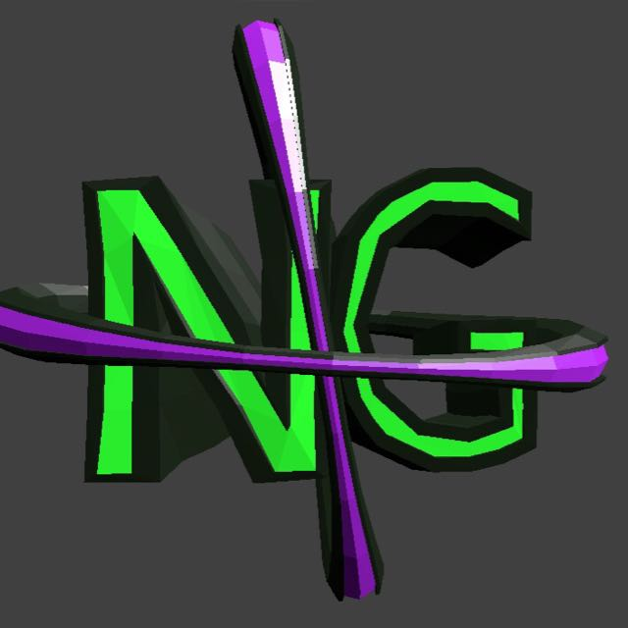

New Game Plus

Professor: Galal Hassan

Students:

* Brody Paterson Mulligan
* Ekin Karayalcin
* Ricardo Shimoda Nakasako

Upon this document we agree that:

1- We are going to uphold the coding standards to the utmost

2- We will create an open source Game engine focused, initially, on supporting our game, Colour Crisis, but always open to extend it

3- We are committed to creating the project in mandatory weekly increments

4- Task status will always be updated in Trello

5- We are aiming at an A-A+ grade for this class

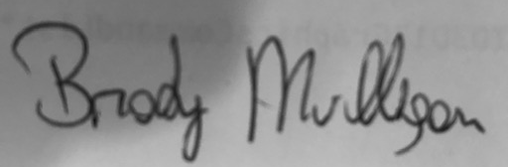

______________________________

Brody Paterson Mulligan



______________________________

Ekin Karayalcin

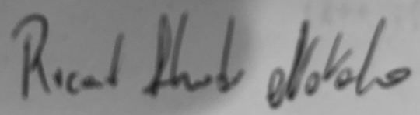

______________________________

Ricardo Shimoda Nakasako